Outdated: Using Geographic Calculator to Convert From One Coordinate System to Another

(Written Jul 27, 2015 by Marianne Okal, for Blue Marble Geographic Calculator 2014)
This document outlines how to use Geographic Calculator to convert:
- Single coordinates
- One file
- Batch conversion of multiple files

Converting Single Coordinates
- Open Geographic Calculator and Check Out a license if necessary.
- Click on “Interactive Conversion” in the Project menu on the left:
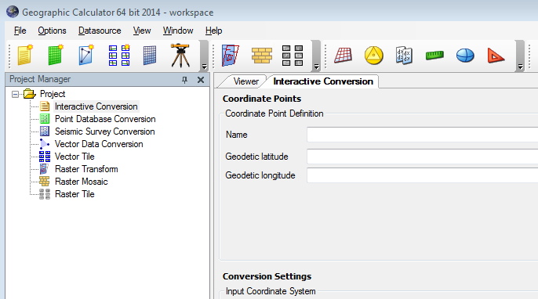
- In the Conversion Settings window, double click on the System entry in the Input Coordinate System area (left) and select the original coordinate system in the new window (below). In the Output Coordinate System area (right), do the same and select the desired, or output, coordinate system. These actions will update the top of the window, where you will enter in the coordinate you wish to convert.
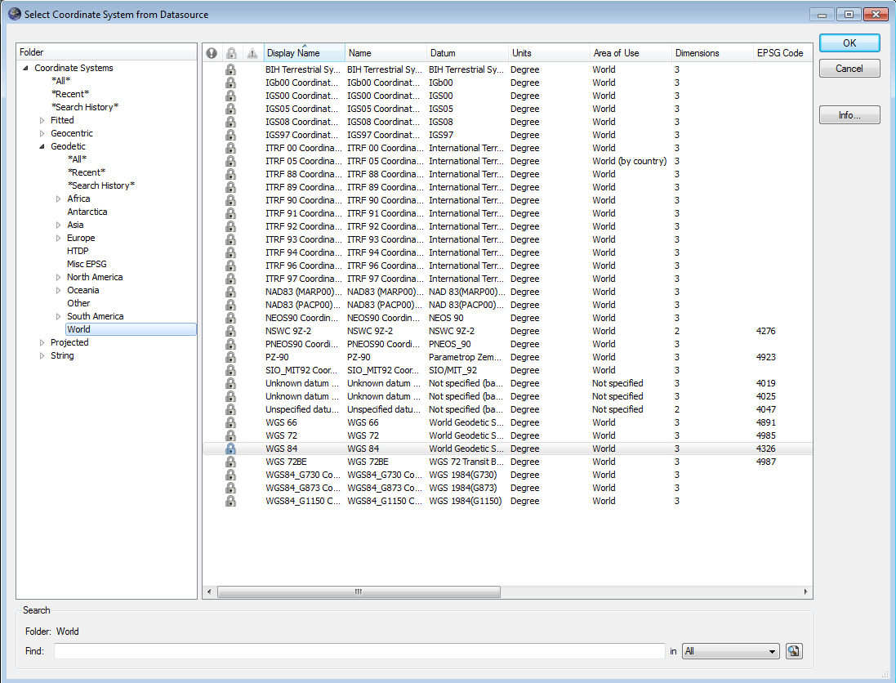
- In the top of the conversion window, enter the coordinates of the point you wish to convert, and push the Calculate button to convert:

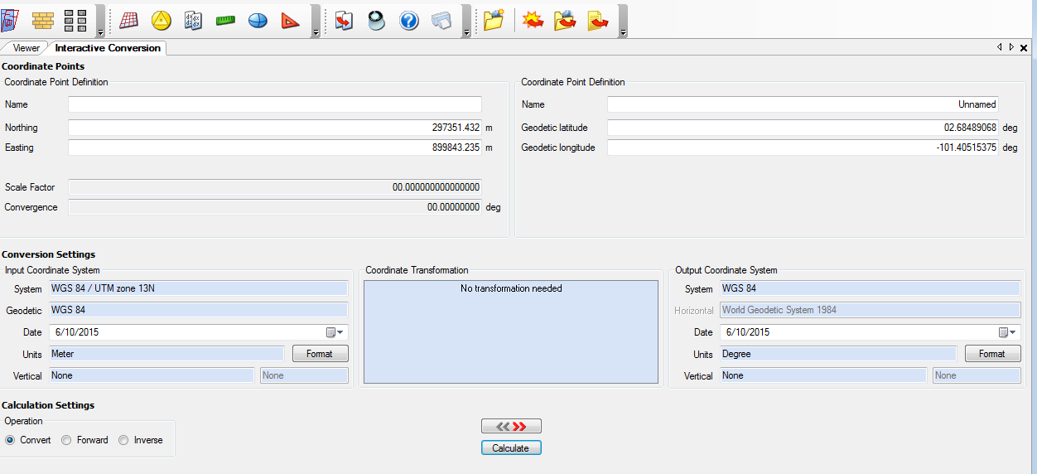
Note: you may need to provide a Coordinate Transformation depending on the type of conversion you are performing. To do, double click in the large blue box and select the correct transformation from the window that pops up.

Converting a Single File of Data
- Open Geographic Calculator and Check Out a license if necessary.
- Click on “Vector Data Conversion” in the Project menu on the left:
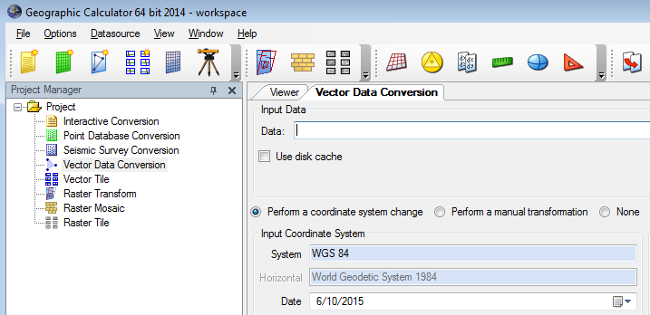
- In the Conversion Settings window, double click on the System entry in the Input Coordinate System area (left) and select the original coordinate system in the new window (below). In the Output Coordinate System area (right), do the same and select the desired, or output, coordinate system. These actions will update the top of the window, where you will enter in the coordinate you wish to convert.
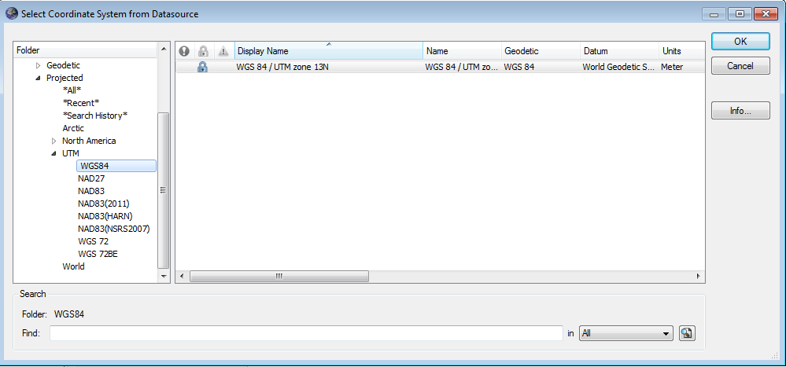
- In the top of the conversion window, where it says Input Data, browse to the data file you wish to convert.
- In the Output Data, browse to the folder you wish to output the converted file. Provide a name for your output file.
- Click on Process; when the program has finished, your output file and a metadata file should be located in the folder you designated.

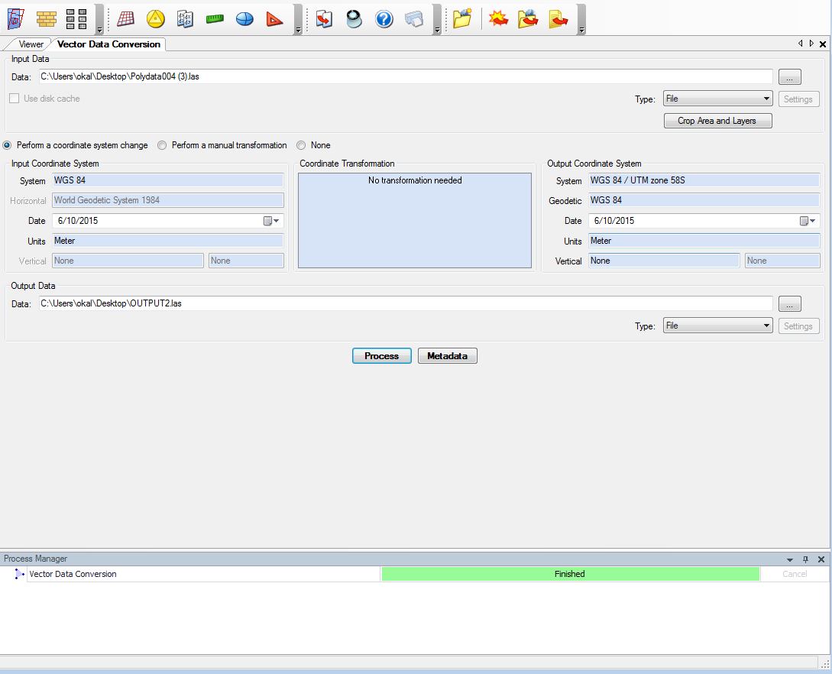
Note: you may need to provide a Coordinate Transformation depending on the type of conversion you are performing. To do, double click in the large blue box and select the correct transformation from the window that pops up.

Batch Conversion of Multiple Files
- Open Geographic Calculator and Check Out a license if necessary.
- Right click on “Vector Data Conversion” in the Project menu on the left and select “Batch Add…” :
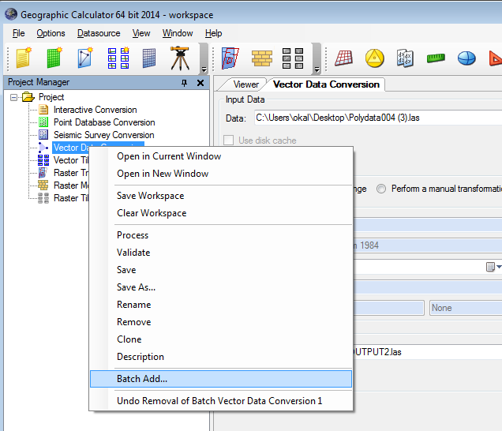
- In the batch conversion window, follow the steps outlined below:
  - First select your input data by browsing to the files you wish to convert; the list of files should appear in the white window in the upper left.
  - Double click on the System entry in the Input Coordinate System box (left) and select the original coordinate system in the new window (below). Make sure “Use coordinate system below” is selected.
  - In the “Coordinate Transformation” area, click “Apply coordinate transformation”. Select a transformation if needed by double clicking in the blue transformation box.
  - In the Output Coordinate System area (right), click “Use coordinate system selected below” and select the desired, or output, coordinate system.
  - Change the parameters in the Output Modifier as desired.
  - Finally, pick the output destination (bottom box).
  - Your batch conversion window should look similar to the image below. Click Generate.
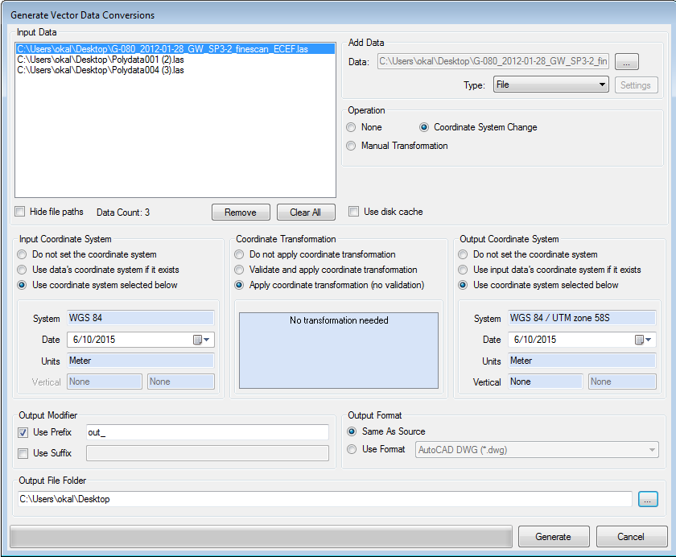

- When you are ready to process the batch, right click on the job you created in the left menu, and select “Process”.


