Review of EFOY Pro 1600

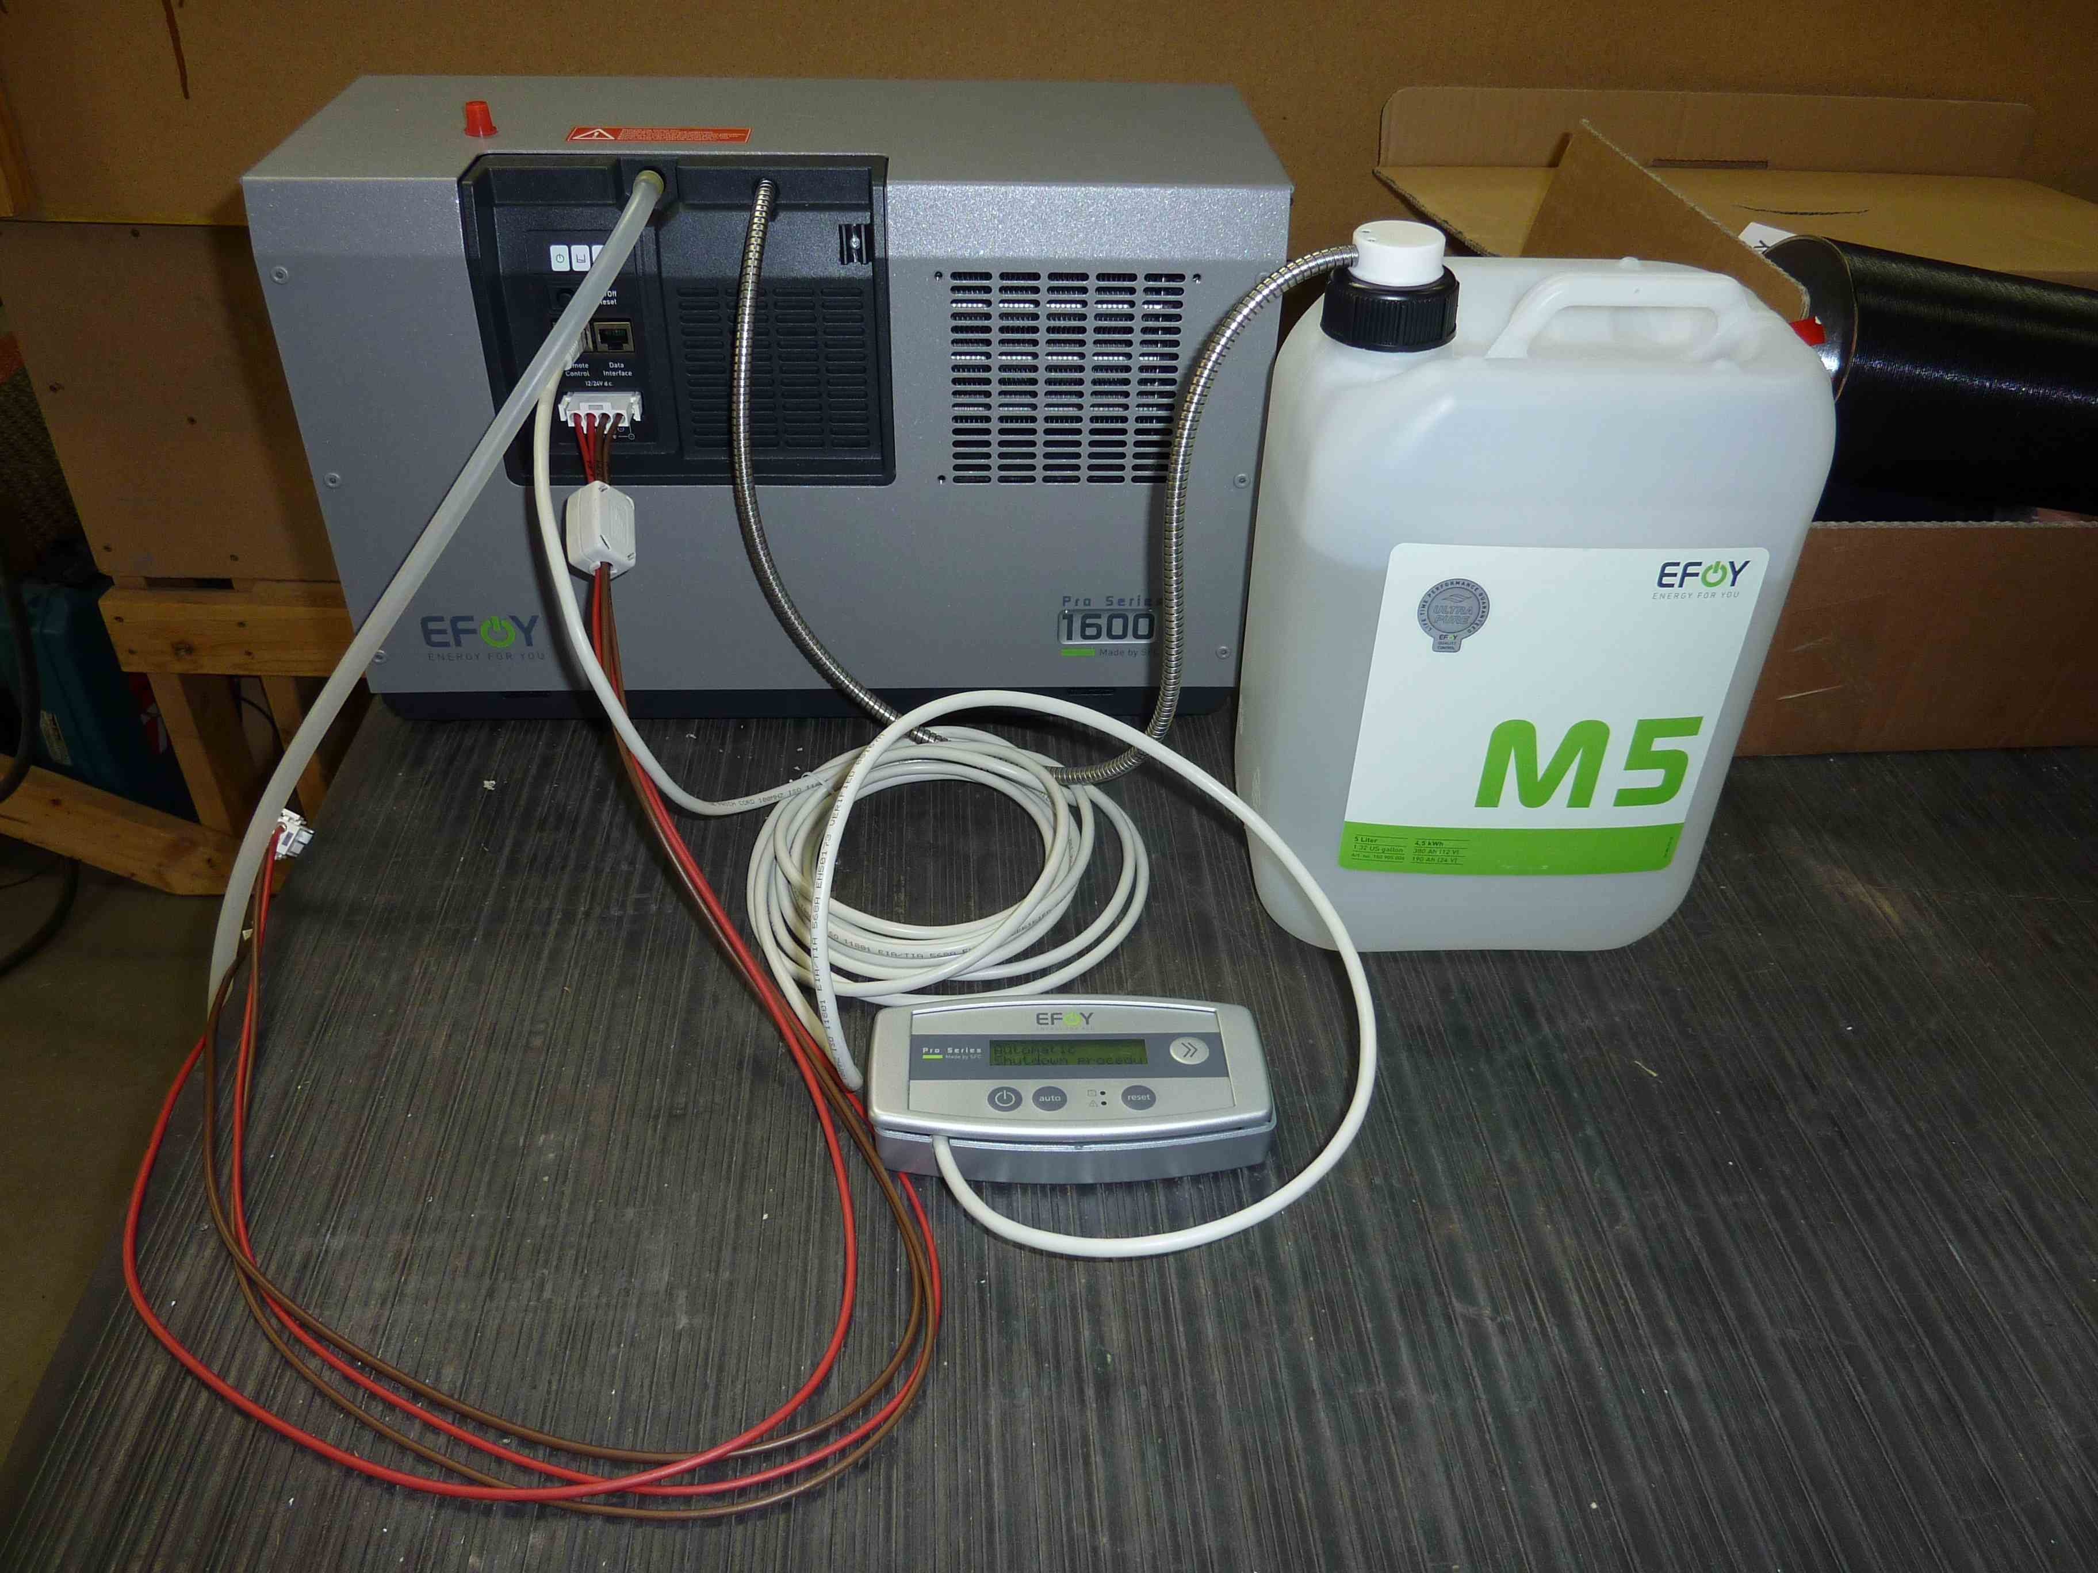

Basic Specifications;
-EFOY Pro 1600
-65W nominal output
-5.4A@12V or 2.7A@24V nominal charge conditions (unit will autodetect)
-Minimum start up Voltage 10.5V or 21V
-0.9liter/kWh under normal operation
-While running at 65W power output will produce 152W waste heat
-One M28 fuel container will produce 30.8Kg of CO2
-Serial port for remote control and SOH
-The cell has 3000 – 6000 hrs operating life depending on operating conditions
--20C - +45C (-2F – 113F) operating range
-0 – 5000ft operating range (8000ft with firmware change)
Physical;
-18.5lbs
-17L x 8W x 11H inches

Fuel Cartridges-
 | M5 | M10 | M28 | M28 x 2
Volume l/gal | 5/1.3 | 10/2.6 | 28/7.4 | 56/14.8
Weight kg/lb | 4.3/9.5 | 8.4/18.5 | 22/48.5 | 44/97
Rated Capacity kWh | 5.5 | 11.1 | 31.1 | 62.2
Art. No.: | 150 905 006 | 150 905 008 | 150 905 040 | 150 905 040 x 2

Documents for EFOY units;
-User manual- “UM-GB-080910 User Manual EFOY Pro Series.pdf” (151 901 070)
-Duocart Switch- “UM_D_GB_DuoCartSwitch_021109.pdf” (151 901 079)
-Data Interface- “data interface.pdf”
-Sirius Integrator Fuel Cartridge Information- “Methanol.pdf”
-EFOY fuel usage calculator- “EFOY Calculator for customers v3.0 EN.xls”

For long term operation the first testing was preformed using-
-2 M28 fuel containers (150 905 040)
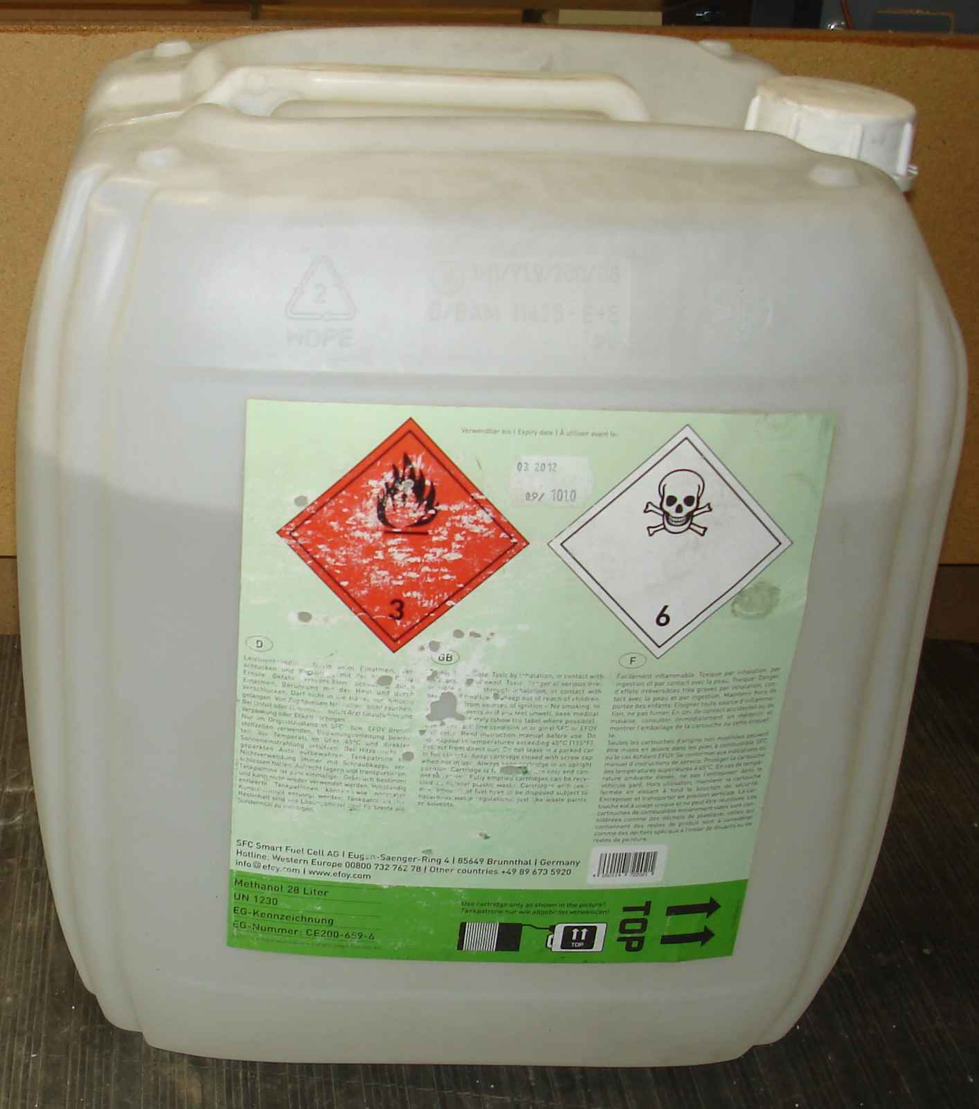

-2 M28 adaptors (151 905 012)
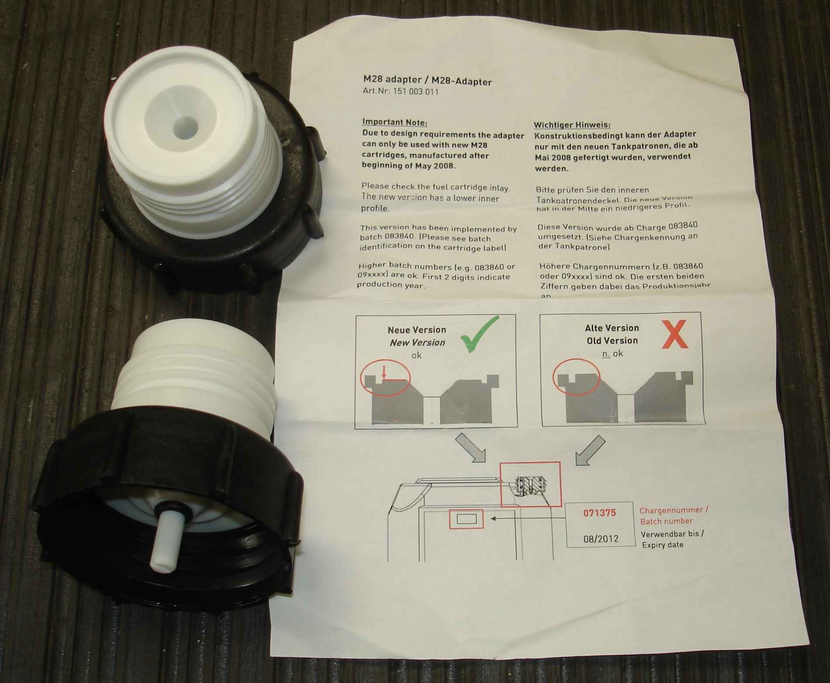

-DuoCartSwitch DCS1 (151 000 189)
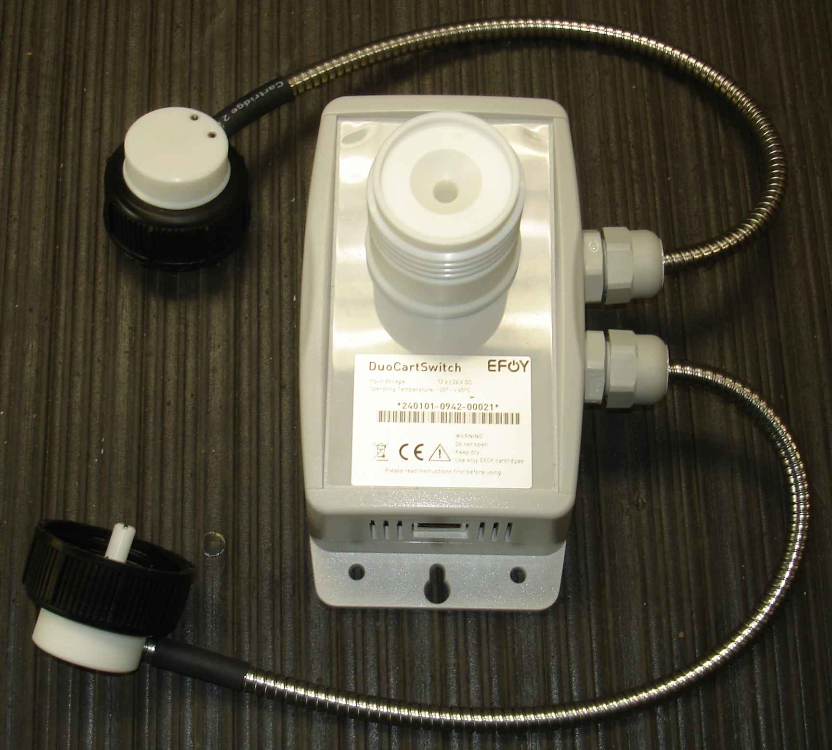

-Port Doppler (RJ45-2x1.1).
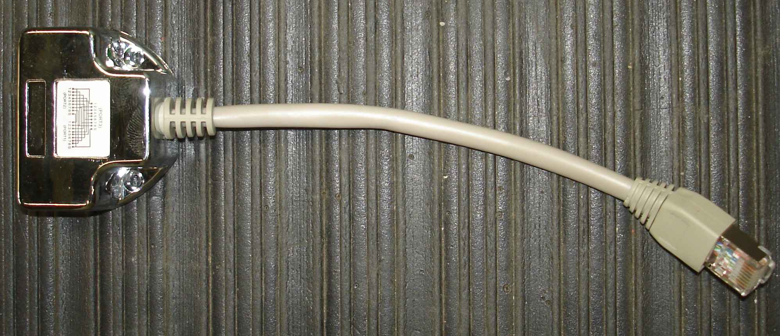

In order to use both the DouCartSwitch and the serial port-
-Connect an Ethernet cable to the EFOY Data Interface port and the Port Doppler on the DouCartSwitch.
-Connect another Ethernet cable from the Port Doppler to the Interface Adaptor IA1.
-Connect the AI1 adaptor to either you PC serial port or the serial input of the B&B serial to Ethernet adaptor.
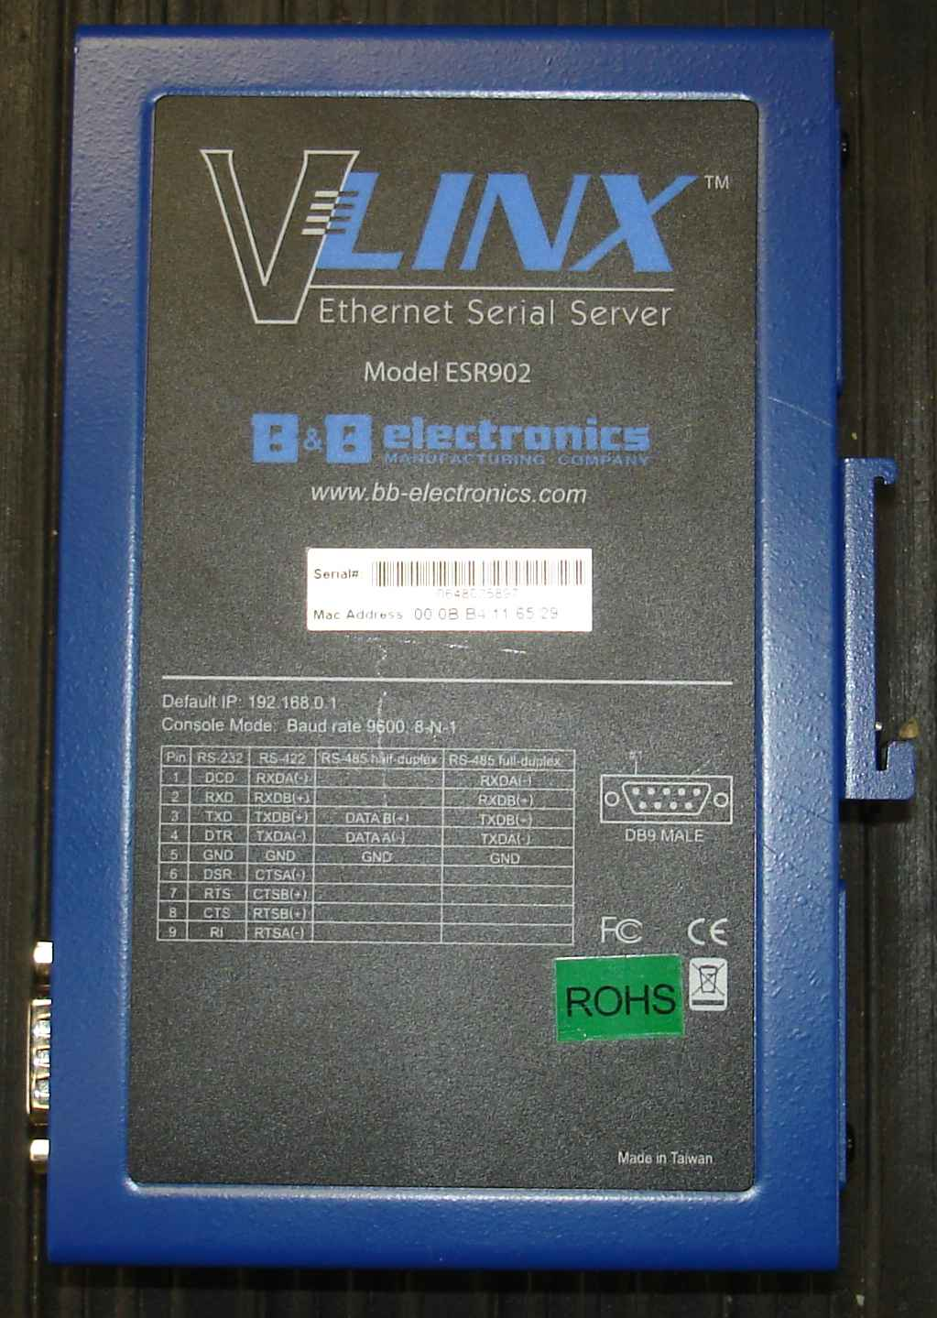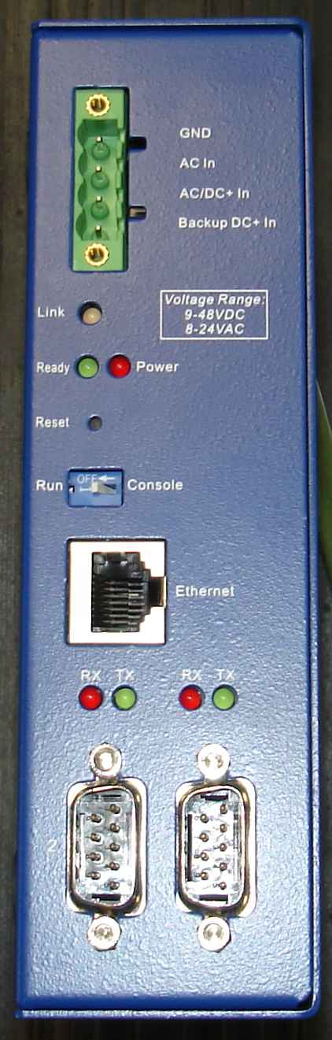
-Connect the programmed B&B serial to Ethernet adaptor to the local network.

Final fuel and communication configuration
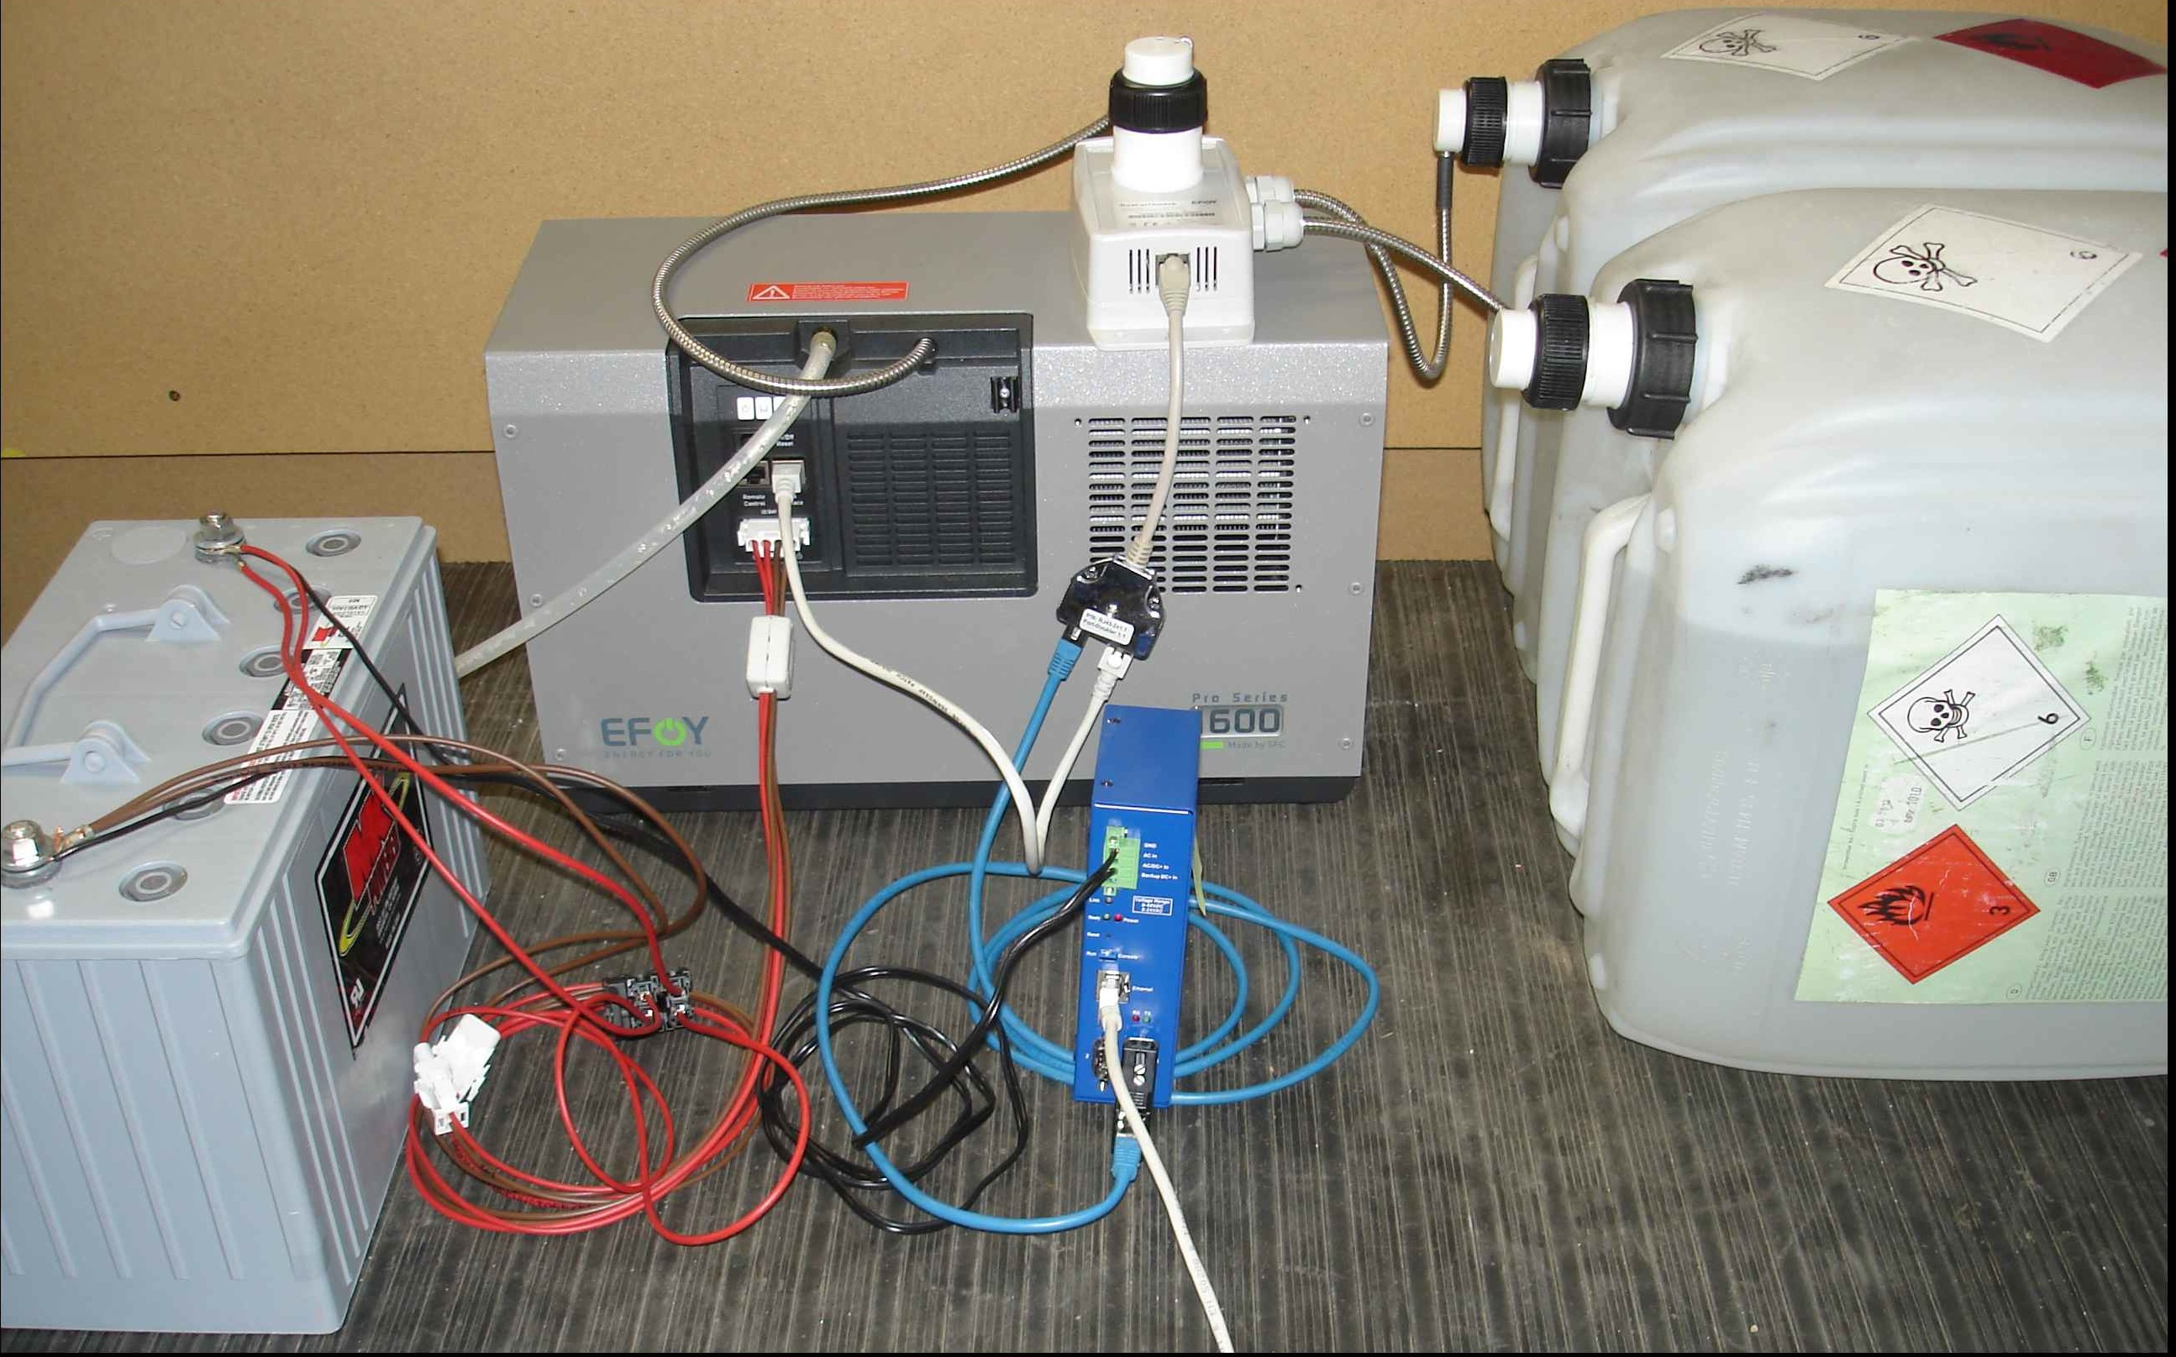

Remote Access-
The serial port is connected via interface adaptor IA1 (151 075 001) or equivalent. The adaptor can be made using the information in section 7.1 of the Users Guide. Do not use a standard RJ45 to DB9 adaptor since there is battery voltage on pin 5 of the RJ45. The serial adaptor from the EFOY is plugged into a “B&B Electronics” model BB-ESR902 serial to Ethernet adaptor. The adaptor is programmed with IP information specific to the site so remote access can achieved via telnet.
If when executing command in telnet window the lines over write perform the following. Escape to the telnet prompt. Type “set crmod” enter enter. You should be back at the SFC prompt and the lines should now appear OK.

Telnet Command window:
SFC>?
command | description
? | display command overview
BUTTON | software control of device
CONFIG | set customized operation parameters
DEFAULT | apply default operation parameters
DUOCARTSWITCH | control DuoCartSwitch device
ERROR | show five most recent errors
HYBRID | switch the device from automatic into hybrid mode for 15s
LANGUAGE | set language for panel
LIMITS | show limits of operation parameters
LOCKED | lock control contacts
REMOTE | remote control via software interface
RESET | restart the device
SERIAL | show the device's serial numbers
SFC | show current operation state
STDVALUE | show default values of operation parameters
VALUE | show current values of operation parameters
VER | show version of firmware

SFC>button ?
software control of device
arguments: ON | OFF | 1/0 | AUTO

SFC>config ?
set customized operation parameters
arguments: ---

SFC>config
switch on voltage @ 12V (actual 12300mV, min 11000mV, max 13000mV)?
switch off voltage @ 12V (actual 14200mV, min 13500mV, max 14700mV)?
switch off current @ 12V (actual 10000mA, min 500mA, max 10000mA)?
switch on voltage @ 24V (actual 24600mV, min 22000mV, max 26000mV)?
switch off voltage @ 24V (actual 28400mV, min 27000mV, max 29400mV)?
switch off current @ 24V (actual 5000mA, min 250mA, max 5000mA)?
reaction time (actual 10s, min 2s, max 300s)?
maximum output energy (actual 1560Wh, min 133Wh, max 7800Wh)?
altitude up to (actual 1500m, min 0m, max 2000m)?
switch on voltage: 12.3V
switch off voltage: 14.2V
switch off current: 10.0A
reaction time: 10s
maximum output energy: 1560Wh
altitude up to: 1500m

SFC>default ?
default ?
apply default operation parameters
arguments: ---

SFC>duocartswitch ?
duocartswitch ?
control DuoCartSwitch device
arguments: {ON | OFF | 1}

SFC>error ?
error ?
show five most recent errors
arguments: ---

SFC>hybrid ?
hybrid ?
switch the device from automatic into hybrid mode for 15s
arguments: {'custom text'} (max. 16 chars)

SFC>language ?
language ?
set language for panel
arguments: {language | show}

SFC>language show
language show
Deutsch
English
Francais
Italiano
Espanol
Nederlands

SFC>limits ?
limits ?
show limits of operation parameters
arguments: ---

SFC>limits
switch on voltage @ 12V: min 11.0V max 13.0V
switch off voltage @ 12V: min 13.5V max 14.7V
switch off current @ 12V: min 0.5A max 10.0A
switch on voltage @ 24V: min 22.0V max 26.0V
switch off voltage @ 24V: min 27.0V max 29.4V
switch off current @ 24V: min 0.3A max 5.0A
reaction time: min 2s max 300s
maximum output energy: min 133Wh max 7800Wh
altitude up to: min 0m max 2000m

SFC>locked ?
locked ?
lock control contacts
arguments: {ON | OFF

SFC>remote ?
remote ?
remote control via software interface
arguments: {ON | OFF}

SFC>reset ?
reset ?
restart the device
arguments: ---

SFC>serial ?
serial ?
show the device's serial numbers
arguments: ---

SFC>serial
efoy : 110303-0936-15911
stack: 151010052-10504

SFC>sfc ?
sfc ?
show current operation state
arguments: ---

SFC>sfc
battery voltage 13.21V
output current 0.01A
operation time (charge mode) 3.3h
operating state: auto off
operating mode: auto
cumulative output energy 311.6Wh
no error
cartridge level above sensor or no sensor

SFC>stdvalue ?
stdvalue ?
show default values of operation parameters
arguments: ---

SFC>stdvalue
switch on voltage @ 12V: 12.3V
switch off voltage @ 12V: 14.2V
switch off current @ 12V: 10.0A
switch on voltage @ 24V: 24.6V
switch off voltage @ 24V: 28.4V
switch off current @ 24V: 5.0A
reaction time: 10s
maximum output energy: 1560Wh
altitude up to: 1500m

SFC>value ?
value ?
show current values of operation parameters
arguments: ---

SFC>value
switch on voltage: 12.3V
switch off voltage: 14.2V
switch off current: 10.0A
reaction time: 10s
maximum output energy: 1560Wh
altitude up to: 1500m

SFC>ver ?
ver ?
show version of firmware
arguments: ---

SFC>ver
Firmwareversion V03 9.17I12V/24V QB date 2009-09-16

The system has a reservoir on the output that contains a “Service Fluid”. This fluid is a 1% solution of Methanol and pure water. Some of the output gases are recirculated to aid in proper cell hydration. During normal operation the moisture contained in the output gas maintains the fluid level. During long-term storage or periods of inoperation this fluid can evaporate. If the unit is to be stored for more than a few months or transported where the unit may tip the output port should be capped. Once the unit is placed back in service the fluid should be topped off if there has been loss. A 100ml container of “Service Fluid” (150 903 001) comes with the new unit. If the fluid get low a “Error 30, 31” will be displayed.
If the unit is installed and power demand is such that the unit does not run monthly the manufacturer suggests a manual or remote start/charge cycle be performed once per month. This situation might occur during the summer when the unit is connected in parallel with solar panels and they pick up the bulk of the charging.
When setting up a new unit configure altitude and adjust switch on /switch off voltages and currents as needed. The parameters for start up, charge, and shut down are adjustable and can be customized based on connection topology using the “config” command. Later these parameters can be adjusted remotely to fine tune the operation of the system.
The charge cycle consists of a startup, charge and shutdown period. During startup and shutdown the unit is warming up or cooling down and the charge power is ramping up or down. The start up and shut down period takes approximately 20 minutes each depending upon operating conditions. Once the warm up period is done the unit will output full charging power until close to the end of the charge cycle when it will start to taper off before entering the shut down phase. The duration of the charge cycle depends completely on load, battery bank capacity and operating conditions.
The unit produces the most heat during the charge cycle. This heat is transferred with a small fan from the back center past the fuel cell stack to the output near the front center. Tested under lab conditions we saw 78F input and 129F output at 4.7A and 14.1V near the end of the charge cycle.
Set up of the unit requires consideration of the operating conditions. It requires air (oxygen) and methanol for fuel and air for cooling. Output consists of mostly CO2, water vapor and waste heat. The CO2 and water vapor are carried out through a ¼ inch ID tube and the heat is transferred as described above. In order for the cell to start up it needs to be between +5 to 45C (41 to 113F).
For operation in cold environments;
Use a slightly ventilated enclosure to maintain input requirement and vent so that moisture does not freeze or otherwise block the output. Consider using thermal mass (batteries) and insulation to level daily temperature fluctuation. Be sure to leave enough room around the unit for good circulation. If temperature drops below 5C (41F) antifreeze mode will kick in. ** In this mode the unit will start the charge cycle until it warms the fuel stack sufficiently then shut down. By running in this mode it can operate to the specified conditions of -20C (-2F) and below this temperature it will not start. Repeated freezing below -20C (-2F) will diminish performance. Unit should sit for 24 hrs after freezing below -20C (-2F) before restarting. Operating in antifreeze mode consumes about 10liters per five month season.**
If unit freezes it will display an “Error 40”. If this happens the unit should be allowed to defrost for about 24 hours before being restarted.

Operation in hot environments;
Place unit in large ventilated and shaded enclosure and use batteries as thermal mass. If the temperature rises above 45C (113F) the unit will not start or if it is running it will shut down. An overheated unit will display an “Error 32, 41”. The unit will restart once the temperature has dropped.

Parallel operation with solar.

Battery connection. Be sure to hook up both the power wire and the sense wire to each of the battery terminals.

Installation
-venting heat
-venting output gasses
-other considerations

Custom adjustments

System efficiency

Output gasses

Output noise or ripple
10mS pulses on charge current

